**Personal Notes**

(Used in combination with Camera for Interactive Display & Position Tracking, or 3D scanning & printing)

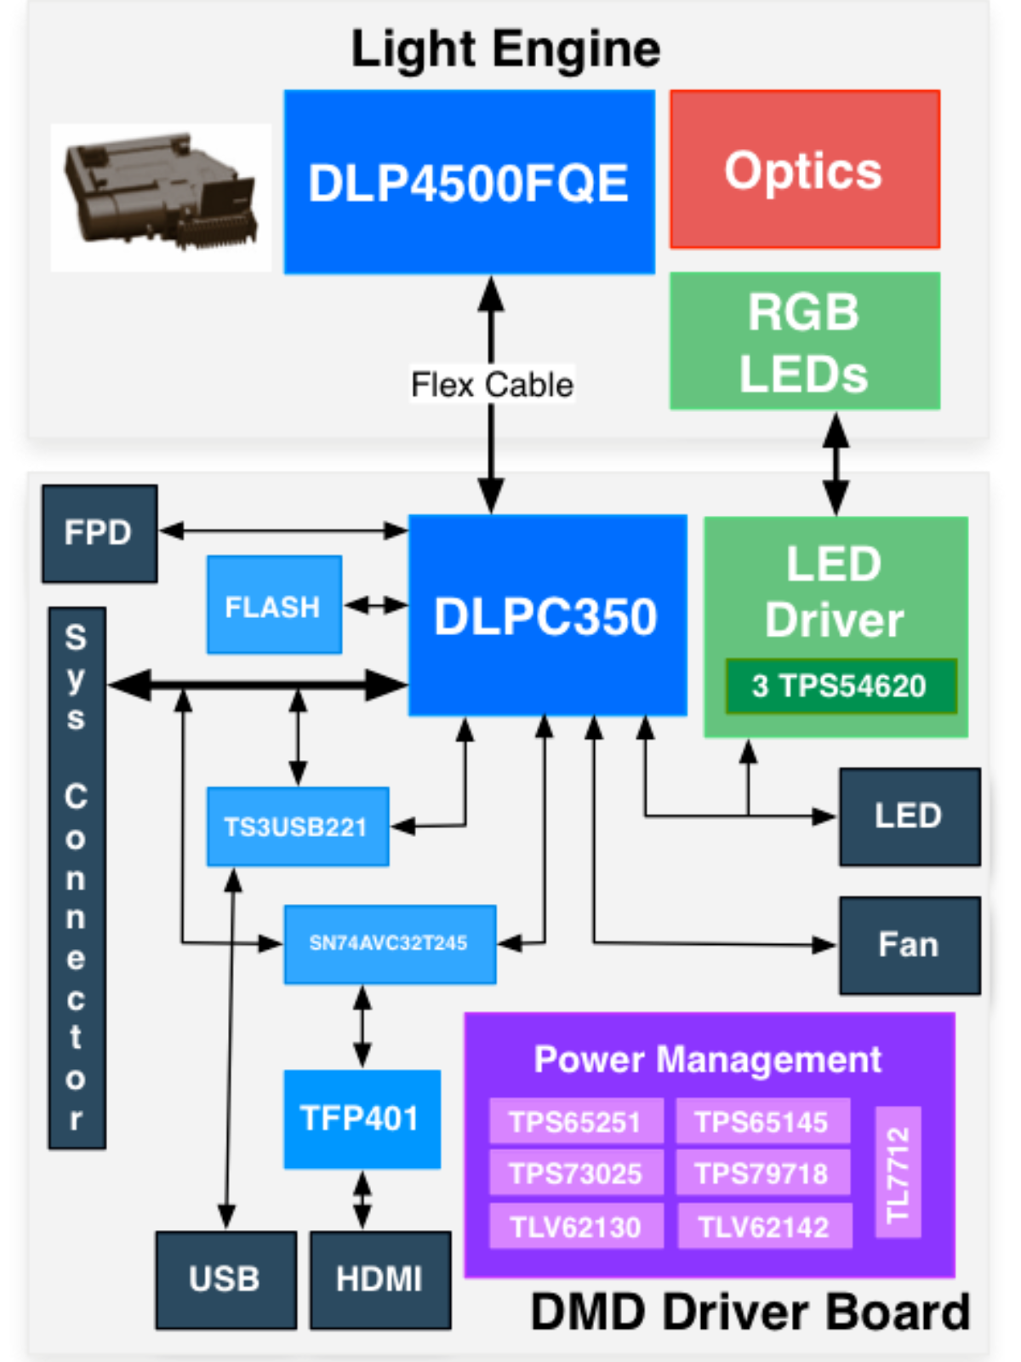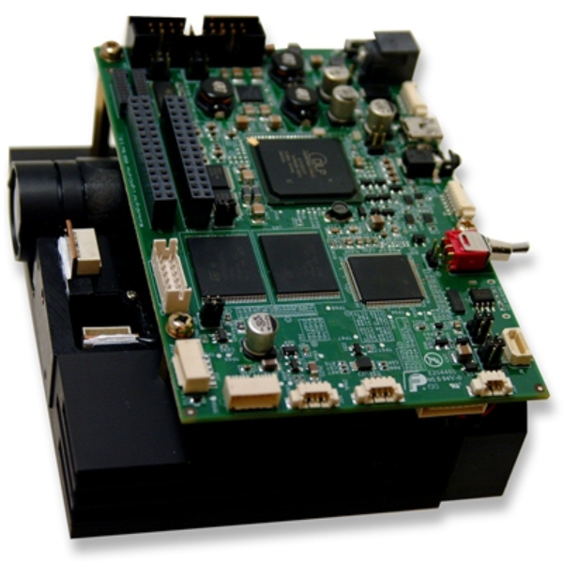

DLP LC EVM (Evaluation Module/Kit):

* Light Engine
  + RGB LEDs
  + WXGA DMD

**-> 912x1140** diamond **pixels**

* + Heat Sink, Fan, Lens/Optics
* Driver Board
  + LED Driver
  + DMD Controller
  + Power management
  + DVI to RGB conversion w/ TFP401
  + 32MB Flash mem (Firmware & 24 Bit compressed images)

0.45 WXGA chipset:

* DLP4500 – 0.45 WXGA FQE, FQD DMD
  + - DLP4500 **digital micromirror device** (DMD)
    - FQE/FQD are the two package types
* DLPC350 – DLP4500 **controller**
* Flash memory w/ config and firmware

|  |  |  |  |  |
| --- | --- | --- | --- | --- |
| Parameter | Min | Typ | Max | Unit |
| Brightness |  | 150 |  | Lm |
| LED Power Consumtion |  | 15 |  | W |
| Full-on Full-off contrast |  | 1000:1 |  |  |
| Uniformity | 80 | 90 |  | % |
| F-number |  | 2.1 |  |  |
| Throw Ratio |  | 100 |  |  |
| Offset |  | 100 |  | % |
| Focus Range | 0.5 | 1 | 2 | M |
| Img. Diag | 42.4 | 83.3 | 165.1 | Cm |

Driver Board Interface

* I2C, UART/RS232 (115200bps)
* Video DVI -> Mini HDMI, and FPD-link connector (FlatPanelDisplay)
  + - Video Mode: display algorithm optimizes appearance, **not pixel accurate**
* Mini USB 1.1
* Trigger in/out
* System Board Interface
* PandaBoard 4500

To Consider:

Power Consumption (Light engine [actively cooled] thermal limit: LED currents <= 4.3 A)

-> Do not overheat system by driving all LEDs at max power

-> LED Driver up to 5A per LED (TPS54620)

Air circulation if EVM is in the case

Color (y/n)?

How many pixels are read by the photodiode at once?

Are neighboring pixels overlaying?

Extra fan for higher LED current

Power management:

TPS65251: Triple output buck (max 2.5,3.5A): DLPC350 1.2V, 1.9V supplies and 5V board supply

TPS65145: Triple output boost (typical limit 1.4A): DLP4500 8.5V, –10V, and 16V supplies

TPS73025: Step-down (max 0.2A): DLP4500 2.5V supply

TLV62130: Step-down (continuous 3A): 3.3V supply

TLV62130: Step-down (continuous 3A): 5V system board supply

TPS79718: Step-down (Continuous 0.01A, limit 0.3A): DLPC350 1.8V analog supply

TL7712: Programmable time delay for power-supply sequencing

3x TPS54620: LED Driver ‘up to 5A per LED’ (Datasheet: 6A each)

TI Software

DLP-ALC-Lightcrafter SDK (Dev. Kit for DLPC350 and others)

DLPLCR4500GUI (GUI)

DLPR350PROM (Config & support Firmware)

LED Current

Red LED Current (A) = 0.0175 × (LED Current Value) + 0.4495 (1)

Green LED Current (A) = 0.0181 × (LED Current Value) + 0.3587 (2)

Blue LED Current (A) = 0.0160 × (LED Current Value) + 0.1529 (3)

Total Current <= 4.3A!

Example from Datasheet: 104, 135, 130 (Which should result in a current of 7.3 Amps)

Notes on GUI

Some commands may require additional steps before the GUI display is updated

Auto Update Status: […]. While running in Pattern Sequence Mode, keeping the option unchecked prevents the GUI from interrupting the DLPC350 controller which will be processing critical functions related to pattern display.

Video Mode RGB Setting range: 0 – 1023 each

White = 1023 Red + 1023 Blue (@104/255 red and 130/255 blue current)???

Operating Modes

Parallel RGB interface: DVI or Sys Board

1-8 Bitmap streamed via 24 Bit RGB interface (mini-HMDI)

Warnings

Don’t look into the Laser (Risk Group 2)

EMV is ESD sensitive